Title with minimal capitalisation: A model paper
Author name¹, Author name²
¹Author affiliation
² Author affiliation
Email for correspondence (presenting author): author@organisation.xxx

Abstract
This template should be used by all authors preparing papers for the ATRF 2026 conference. It contains detailed style and formatting guidelines and instructions for submitting your paper.
If you have any questions about the paper submission process, please contact the conference secretariat by emailing atrfsc@gmail.com

Introduction
This template models the layout and formatting requirements for all ATRF 2026 papers, both Research and Professional Practice Papers.
Please read this document thoroughly before preparing your paper. Papers which do not comply fully with these formatting instructions will be returned to the authors for correction before being submitted for review. The easiest way to prepare your paper is to cut and paste your content into this template. Please use the headings styles provided in this template (e.g. do not just match the headings using bold and text size) as it greatly speeds the process of uploading the finalised papers into the conference proceedings.

Paper length and page set-up
A maximum of 15 pages including the Abstract (max 300 words), tables and graphics, and references. Page size is A4 and margins are 2.54 cm on each side with no gutter. This should not be modified, even for landscape-oriented figures or tables. Blank lines or page breaks may be used to enhance readability when necessary. Use single spacing between sentences.

File format
Papers must be submitted as pdf files with line numbers shown on all lines in the original submission. Line numbers must be removed in the final version of the paper, submitted after authors respond to reviewer feedback.
1.3 Spelling and capitalisation
Please use Australian (UK English) spelling: e.g.; organise, not organize; colour, not color.
Minimal capitalisation should be used in the title of the paper, all headings and sub-headings, and figure and table captions.
Capitalise only the first word of the sentence and proper nouns as shown in this document. This includes the paper title. In the text, capitalise the words Figure, Table, Section, Equation, etc. when referring to specific captioned items or to sections or sub-sections of your paper.

Style guidelines
The predefined MS word text styles shown in Table 1, below, are modelled in this document. Authors using software other than MS Word should use the specifications in Table 1 as a guide.
Table 1: Text styles for ATRF 2026 conference papers
Style | Specification
Paper title | Arial, 16 point, bold, centred
Author name | Arial, 12 point, normal, centred
Author addresses | Arial, 10 point, normal, centred
Abstract heading | Arial, 14 point, bold, centred
Normal (body text) | Arial, 11 point, normal, fully justified
Table text | Arial, 10 point, normal, left justified
Captions | Arial, 10 point, bold, left justified
Page headers | Arial, 10 point, normal, centred
Section heading level 1 | Arial, 14 point, bold, left justified
Section heading level 2 | Arial, 12 point, bold, left justified
Section heading level 3 | Arial, 11 point, bold italic, left justified

Section headings and sub-headings
Section headings and sub-headings should use the styles shown in Table 1, above, and modelled in the examples throughout this document. The Abstract heading is not numbered and is centred on the page. References and Acknowledgements (if used) should use the section heading level 1 style without numbering.

Example of section heading level 3 style
Further levels of headings should use the style for heading level 3 with additional levels of numbering. Before including level 4 or higher-level headings in your paper please consider whether this is absolutely necessary.

Figures and tables
Figures and tables should fit within the page margins and be numbered sequentially throughout the document. For large figures and tables, landscape orientation may be used. In tables which run over multiple pages, column headers should be repeated on each page. Choices related to figure or table styles are up to the author but should be broadly consistent with the rest of the document.
Captions should be numbered separately with sequential integers (1, 2, 3, etc.) and placed above each figure and table.
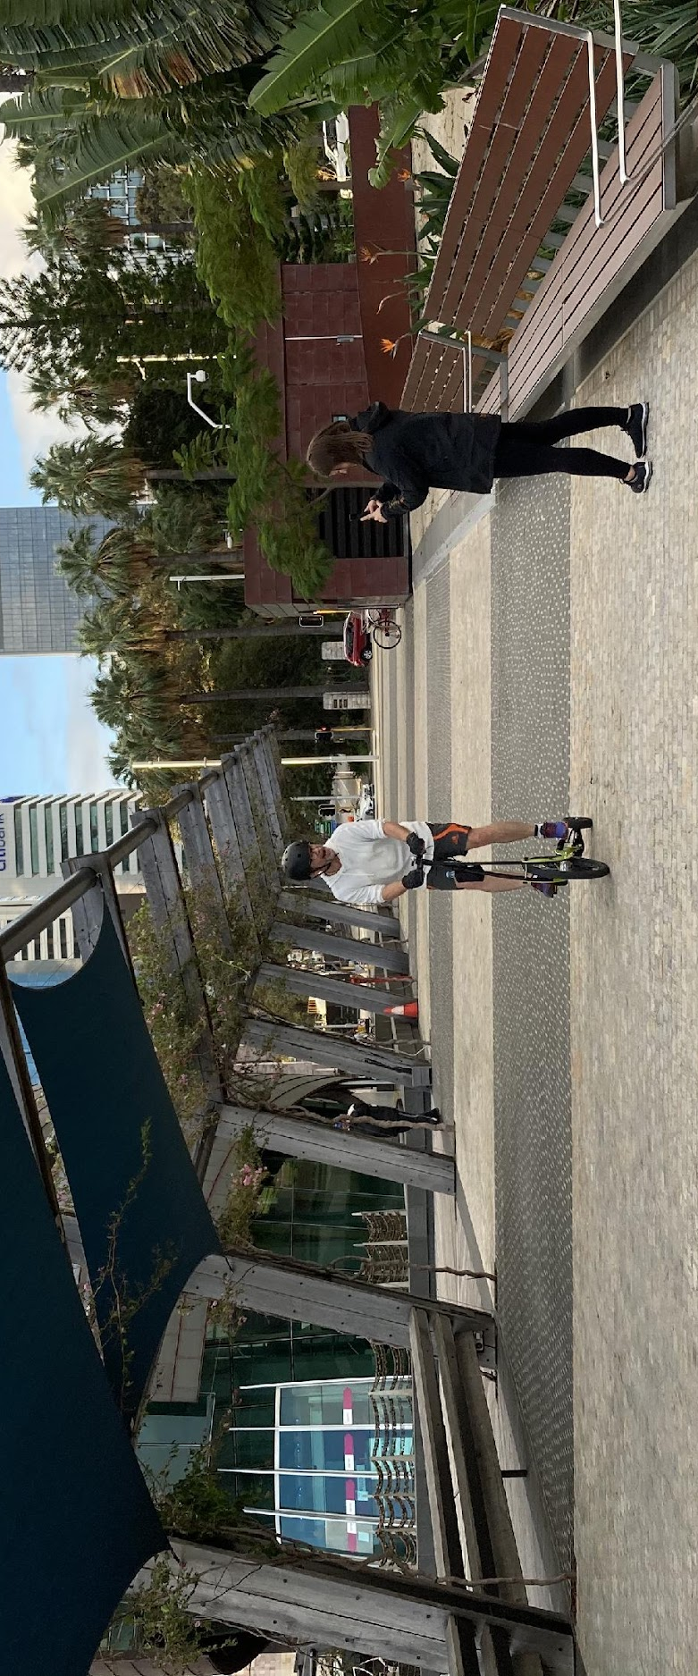
Figure 1: Example figure

Footnotes and equations
Footnotes, if used, should be numbered sequentially throughout the document. Equations may take the numbering scheme and style chosen by the author.

Acknowledgements
Include this heading only if you need to acknowledge a sponsor, institution or study participants without whose assistance the research would not have been possible.

References
Provide a References list (sources cited in the paper), not a Bibliography (everything you have read on the topic). The Harvard (author/date) style must be used. All citations in the paper must correspond to an entry in a separate References section at the end of the paper. Entries should be listed alphabetically by author(s), and then chronologically, not numbered.
See https://guides.lib.monash.edu/citing-referencing/harvard2020-intro for complete guidelines and examples.

